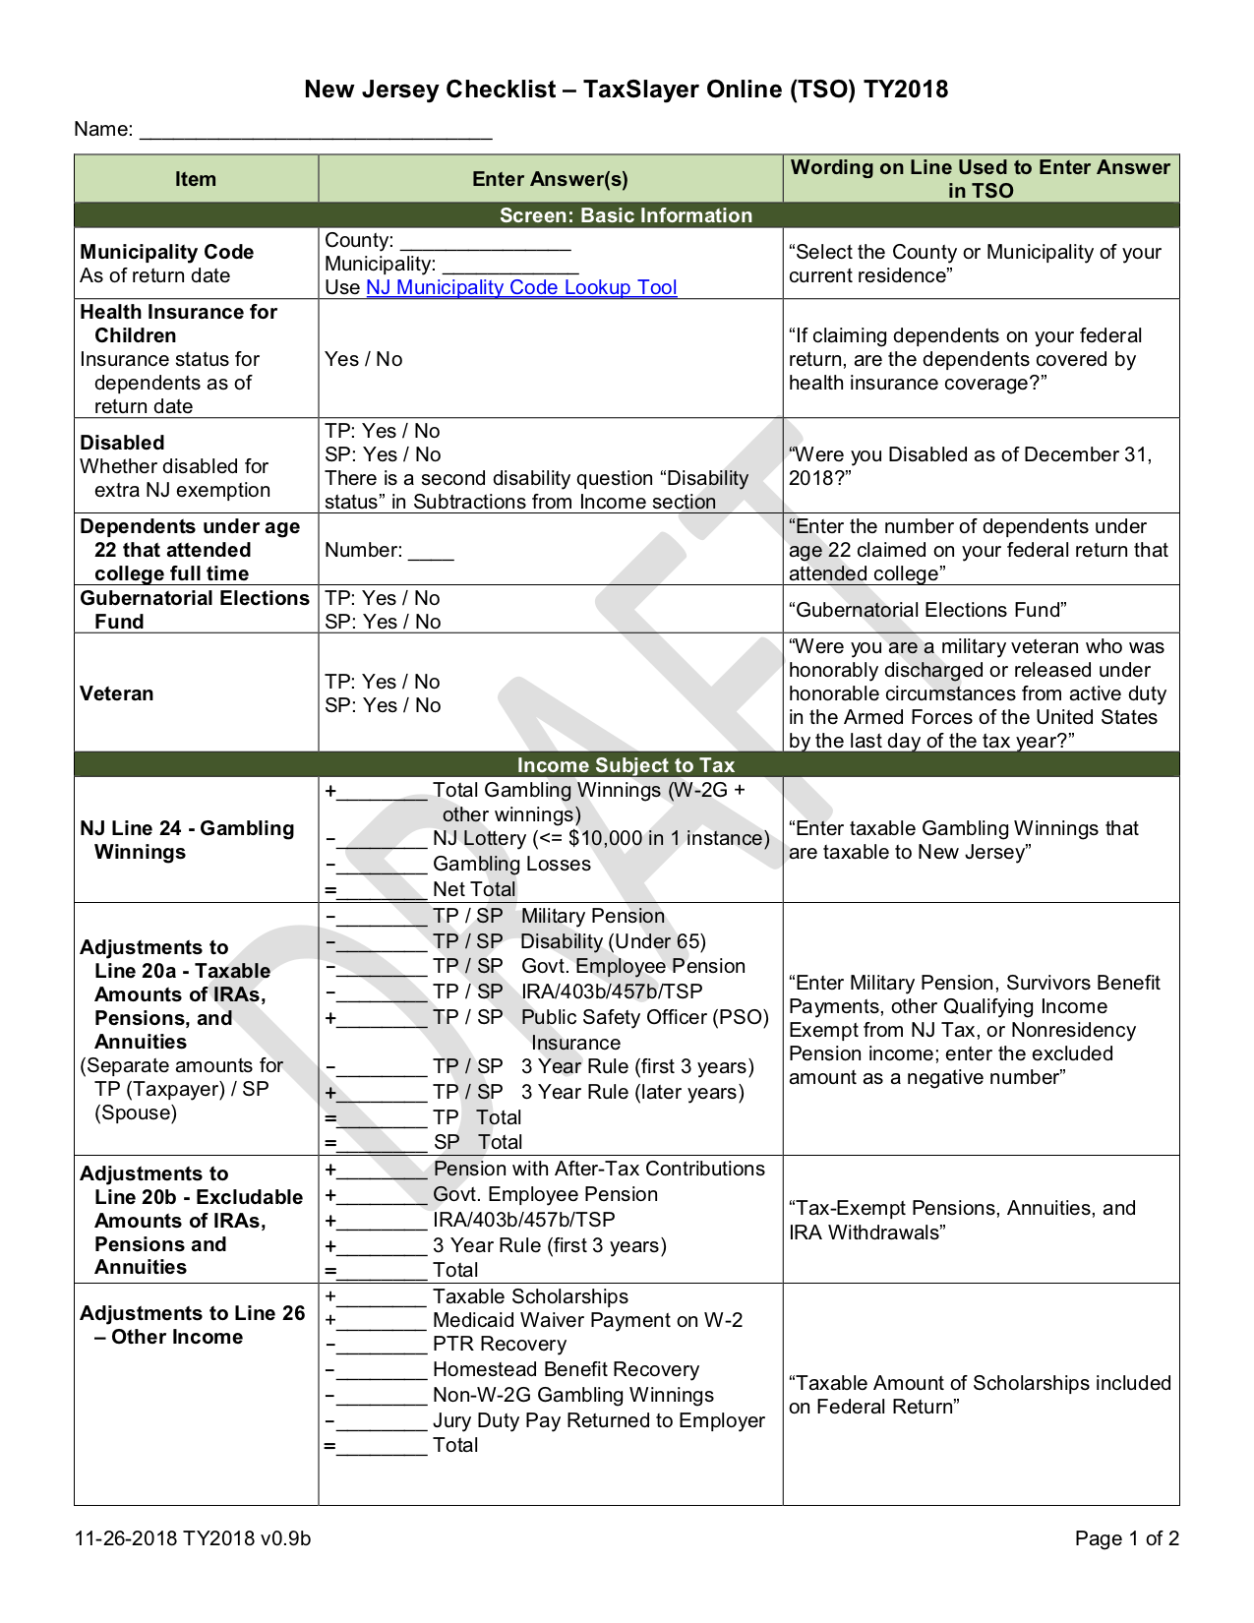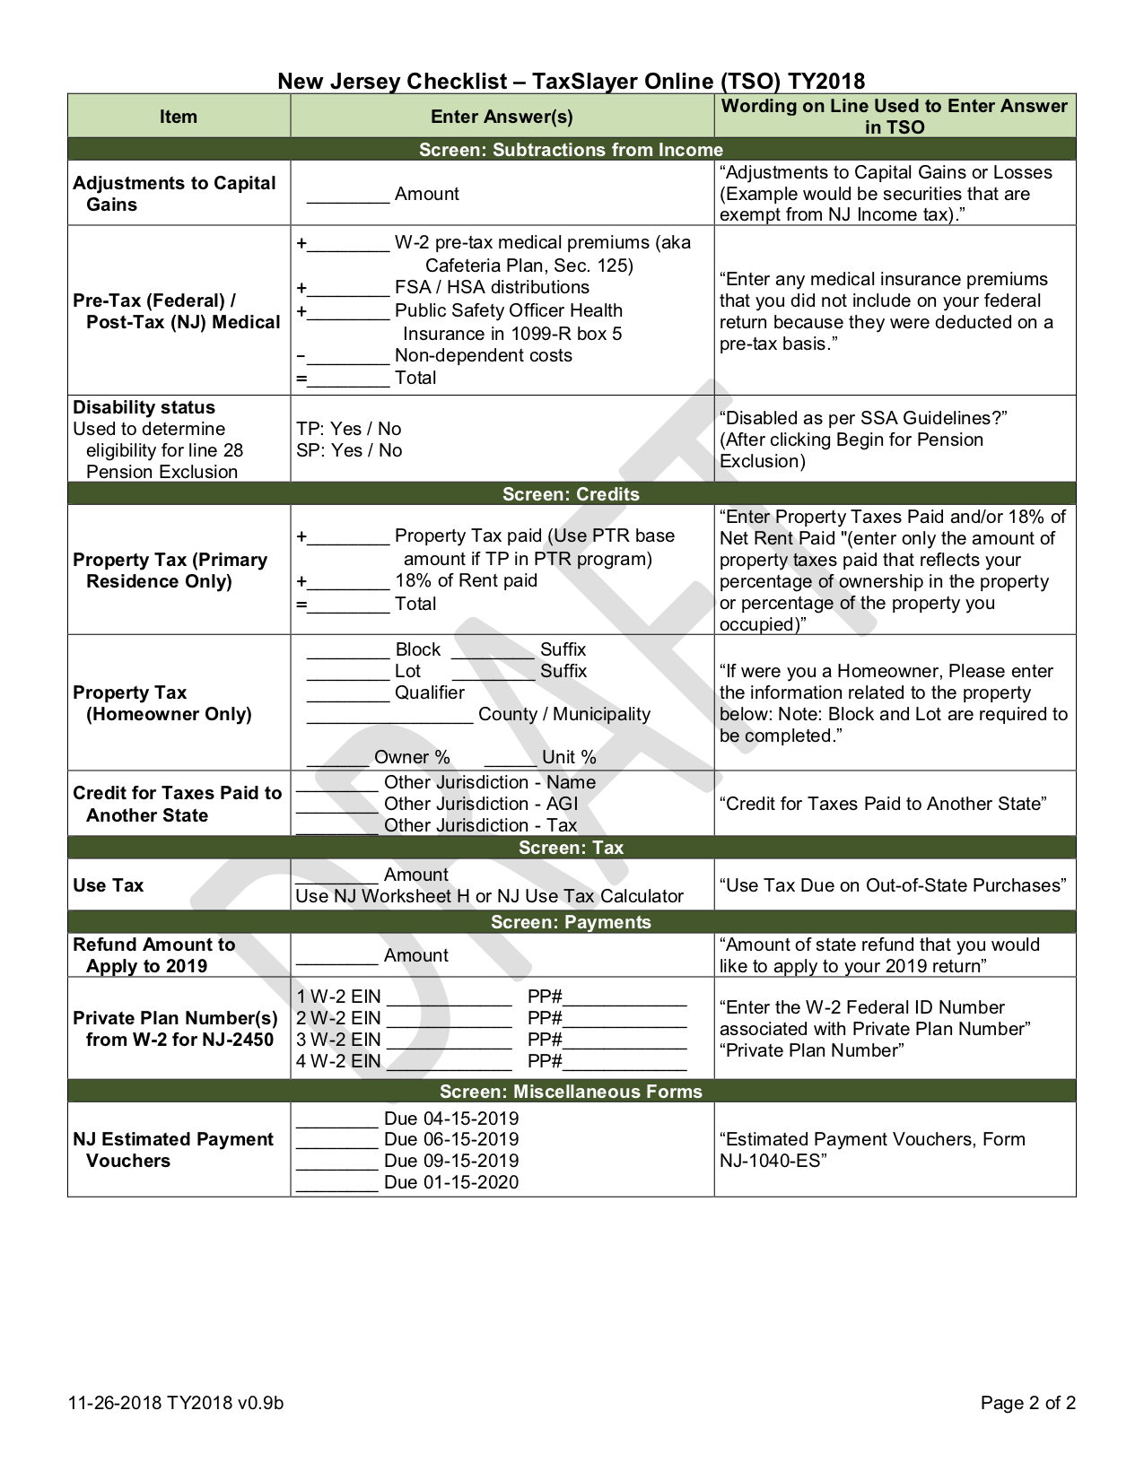

Kent NJ Checklist v0.9g

-1,200

See Scratchpads

Use Zero

1

335

See Annuity Calc

335

1,444

200

1,200

-344

1,300

Kent

Somerset

Bedminster Township

Kent NJ Checklist v0.9g

20

20

20

20

00002

50001

84

6,385

6,385

1,200

1,200